**1**. **Introduction:**

* The project consists of set of webpages for the basic implementation of patient management system for OPD Section of K. J. Somaiya Medical And Research Centre.
* It deals with everything pertaining to the tasks of OPD patients, Doctors and Staff . The databases and the web technology used will make it simpler to meet all the requirements of the Hospital .

**1.1 Problem Definition:**

* The purpose of the project is to deliver a management system for the entire Hospital so as to avoid the traditional management system , and use automated mechanism.
* Another major problem that the hospital is facing that due to manual records, it has lead to less accountability of the different staff present in the OPD. Whether it is the front desk personnel or billing personnel, the more of manual work and handling more papers is not an easy task and therefore, it leads to loss of accountability for the work which is carried out extra due to the manual process (paperwork). It has led only to increase in consumption of stationery and space in the hospital (for storage).

**1.2 Scope :**

The project aims at managing

* Login of users: Admin, Doctor, Receptionist
* Doctor details
* Patient details
* Patient’s medical history
* Generate reports on various basis like monthwise, agewise and genderwise.

**1.3 References**

References used for the above mentioned project includes:

* [www.w3schools.com](http://www.w3schools.com)
* [www.codecademy.com](http://www.codecademy.com)
* [www.wikipedia.com](http://www.wikipedia.com)
* [www.getbootstrap.com](http://www.getbootstrap.com)
* www.tutorialspoint.com

**2. Overall Description**

1. Registration of the Patients: Whenever a new patient is coming for the OPD consultation, the front desk personnel register the patient to the system. The system generates a PID for the patient which is now been used by the other users who are the part of this system. If the patient is old then the front desk personnel search for the patient in the system by using its PID.
2. Patient’s information for Doctor’s reference: The doctor can log into the system and view the information of any patient once the patient’s ID is known. Thus the Doctor has easy access to patient’s medical history.

**2.1 User Interfaces/interfaces.**

## Interfaces:-

For the product to function, the system must include the following classes of interfaces:

* User Interface
* Hardware Interface
* Software Interface
* Communication Interface

The protocol used shall be HTTP (Hyper Text Transfer Protocol).

* User Interfaces

There will be three user types – the Administrator, the Receptionist and Doctor each of which will have its own corresponding interface.

The minimal requirements are that the user would be able to interact with the system through a particular browser and once the user logs in, he/she will be able to access the system and do the corresponding operations.

The user interface for the software shall be compatible to any browser such as Internet Explorer, Mozilla, Google Chrome or Netscape Navigator by which user can access to the system.

The user interface shall be implemented using any tool or software package like Java Applet, MS Front Page etc.

**2.2. Hardware Interfaces (H/W Requirements)**

Since the application must run over the internet, all the hardware shall require to connect internet will be hardware interface for the system. As for e.g. Modem, WAN – LAN, Ethernet Cross-Cable. The additional thing that is to be considered is that, there must be secondary storage / Hard disk of huge capacity so as ensure proper functionality.

**2.3. Software Interfaces(S/W Requirements)**

OPD system will directly interface with the online software which in turn will be interfacing with the operating system and any other software components it requires. For the execution of parallel jobs, there can be many users who can login and do the needful task.

**2.4. Operating environment**

|  |  |
| --- | --- |
| Operating System | Windows XP or above |
| Processor | Core2Duo or above |
| Hard disk | 1GB at least |
| RAM | 512MB at least |
| Type of operation | Web based operation |

1. **SYSTEM FEATURES**

This section describes the functional requirements of the application and the features it provides. System features are described in detail to help the future extension and testing of the system. Features stated here are already parts of the implemented system so no prioritization is needed. Priority is needed for features to be developed that will be added to this document later.

The system functions can be described as follows:

* Login Facility: The site provides login facility to Admin, Doctor and the Receptionist and provides various actions according to the type of the user.
* Registration of the Patients: Whenever a new patient is coming for the OPD consultation, the front desk personnel register the patient to the system. The system generates a PID for the patient which is now been used by the other users who are the part of this system. If the patient is old then the front desk personnel search for the patient in the system by using its PID.
* Patient’s information for Doctor’s reference: The doctor can log into the system and view the information of any patient once the patient’s ID is known. Thus the Doctor has easy access to patient’s medical history.
* Report Generation**:** The system generates the reports as per of the Administrator option selection.

The system shall allow the administrator to send reminders to the consultants about the scheduler updating by the doctor monthly/weekly as needed (optional). The administrator shall be able to update any information in the database.

*Periodic Reports:* The system should generate reports for the number of registration periodically (daily/weekly/ monthly/ yearly).

* Database:The Database will keep all the data which may include Staff Information, The Users who are directly linked to the system and their basic details, all the details of patients.
* Analysis: The system should help the administration to analyse the data with any option present in the database.

**3.1 Navigation**

The use of website navigation tools allow for a website's visitors to experience the site with the most efficiency and the least incompetence. A website navigation system is analogous to a road map which enables webpage visitors to explore and discover different areas and information contained within the website.[[8]](https://en.wikipedia.org/wiki/Web_navigation#cite_note-webpagemistakes.ca-8) There are many different types of website navigation:

* **Hierarchical Website Navigation**

The structure of the website navigation is built from general to specific. This provides a clear, simple path to all the web pages from anywhere on the website.

* **Global Website Navigation**

Global website navigation shows the top level sections/pages of the website. It is available on each page and lists the main content sections/pages of the website.

* **Local Website Navigation**

Local navigation would the links with the text of your web pages, linking to other pages within the website.

The components which makes it more attractive are:

**Interesting Navigation Designs**

* **Beautiful Vertical Navigation Designs**

**3.2 Aesthetic layout**

**Web design** encompasses many different skills and disciplines in the production and maintenance of websites. The different areas of web design include web graphic design; [interface design](https://en.wikipedia.org/wiki/Interface_design); authoring, including standardised code and proprietary software; [user experience design](https://en.wikipedia.org/wiki/User_experience_design); and [search engine optimization](https://en.wikipedia.org/wiki/Search_engine_optimization). Often many individuals will work in teams covering different aspects of the design process, although some designers will cover them all.[[1]](https://en.wikipedia.org/wiki/Web_design#cite_note-different_jobs-1) The term web design is normally used to describe the design process relating to the front-end (client side) design of a website including writing mark up.

Part of the user interface design is affected by the quality of the [page layout](https://en.wikipedia.org/wiki/Page_layout). For example, a designer may consider whether the site's page layout should remain consistent on different pages when designing the layout. Page pixel width may also be considered vital for aligning objects in the layout design. The most popular fixed-width websites generally have the same set width to match the current most popular browser window, at the current most popular screen resolution, on the current most popular monitor size. Most pages are also center-aligned for concerns of [aesthetics](https://en.wikipedia.org/wiki/Aesthetics) on larger screens

For the aesthetic layout , web technologies that will help the end users to be at ease while operating the systems and to easily interpret the things , Cascading Style Sheets, various Bootstrap, and designing methodologies have been adopted.

**3.3 Effective graphic design**

As mentioned above , an effective graphical representation of the web pages is one of the major attribute the developers have to consider .

If the design is not aesthetically approving , it does not make the end users to use it flexibly .

Effective graphic design is thus implemented by using inbuilt tags of html, adapting css and bootstrap methods.

**3.4 Logical database requirements**

For the automation of the entire System , the database is the most essential requirement .

Data pertaining to all actors like Admin , Doctor , and patient have been inserted into the database. The Xampp Apache Server is used . The database used at the backend is implemented in MySql.

Database name : OPDD

Tables used (with structure)

admininfo

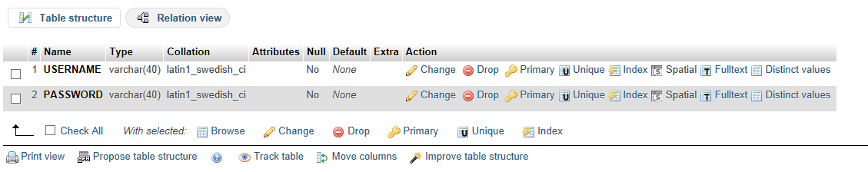

doctorinfo

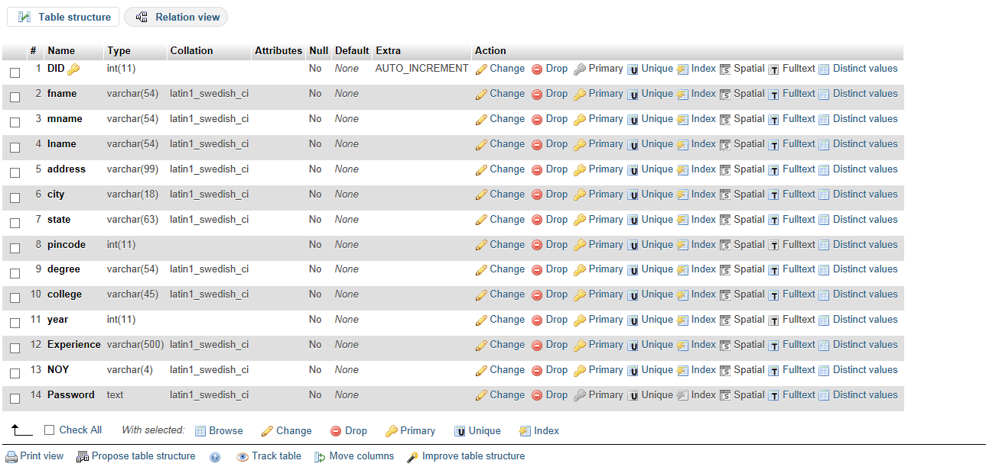

patient

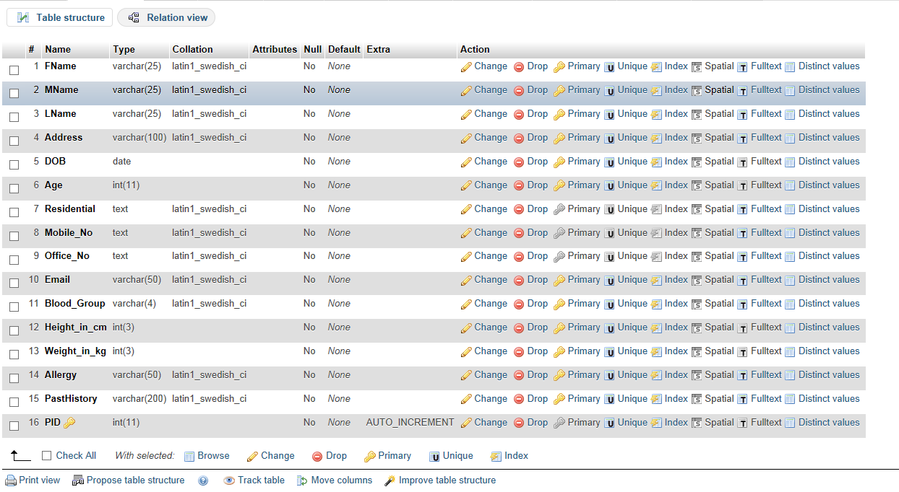

**4. Self-Learning Component**

Self – Learning consists of

* adapting graphics
* using softwares which can directly ease development procedure like Notepad++
* Implementing bootstrap
* referring to prevailing codes
* Understanding the use of css Classes
* Achieving Database integrity
* software quality attributes etc.

**Date: _____________ Signature of faculty in-charge**